2
, QH Lei
1 2
, William J Fisk
Olli Seppänen
Effect of Temperature on Task Performance in
Offfice Environment
1
Helsinki University of Technology,
Laboratory for Heating Ventilating and Air-conditioning,
PO Box 4100, FIN-02015 HUT, Finland
2
July 2006
This work was supported by the Finnish Academy. This work was also supported by the Indoor Environments Division, Office of Radiation and Indoor Air, Office of Air and Radiation of the U.S. Environmental Protection Agency through interagency agreement DW-89-92175001-0 with the U.S. Department of Energy.
Lawrence Berkeley National Laboratory Environmental Energy Technologies Division Indoor Environment Department
Berkeley, CA 94720
LBNL- 60946

EFFECT OF TEMPERATURE ON TASK PERFORMANCE IN OFFFICE
ENVIRONMENT
Olli Seppänen¹, William J Fisk² , QH Lei³
¹Helsinki University of Technology,
Laboratory for Heating Ventilating and Air-conditioning,
PO Box 4100, FIN-02015 HUT, Finland
Email: olli.seppanen@hut.fi
^{2,3}Lawrence Berkeley National Laboratory, USA
²email:wjfisk@lbl.gov
³email:QHLei@lbl.gov
Keywords: productivity, performance, temperature, offices, cost-benefit analysis
ABSTRACT
Indoor temperature is one of the fundamental characteristics of the indoor environment. It can be controlled with a degree of accuracy dependent on the building and its HVAC system. The indoor temperature affects several human responses, including thermal comfort, perceived air quality, sick building syndrome symptoms and performance at work. In this study, we focused on the effects of temperature on performance at office work. . We included those studies that had used objective indicators of performance that are likely to be relevant in office type work, such as text processing, simple calculations (addition, multiplication), length of telephone customer service time, and total handling time per customer for call-center workers. We excluded data from studies of industrial work performance. We calculated from all studies the percentage of performance change per degree increase in temperature, and statistically analyzed measured work performance with temperature. The results show that performance increases with temperature up to 21-22 ºC, and decreases with temperature above 23-24 ºC. The highest productivity is at temperature of around 22 ºC. For example, at the temperature of 30 ºC the performance is only 91.1% of the maximum i.e. the reduction in performance is 8.9%

INTRODUCTION
In many commercial buildings, thermal conditions are not controlled well, due to insufficient cooling or heating capacity, high internal or external loads, large thermal zones, improper control-system design or operation, and other factors. Thermal conditions inside buildings vary considerably, both with time, e.g., as outdoor conditions change, and spatially. While the effects of temperature on comfort are broadly
recognized, the effects on worker productivity have received much less attention.
Increased evidence shows that indoor environmental conditions substantially influence health and productivity. Building services engineers are interested in improving indoor environments and quantifying the effects. Potential health and productivity benefits are not yet generally considered in conventional economic calculations pertaining to building design and operation. Only initial cost plus energy and maintenance costs are typically considered. A few sample calculations have also shown that many measures to improve the indoor air environment are cost-effective when the health and productivity benefits resulting from an improved indoor climate are included in the calculations (Djukanovic et al. 2002, Fisk 2000, Fisk et al. 2003, Hansen 1997, van Kempski 2003, Seppänen and Vuolle 2000, Wargocki, 2003). There is an obvious need to develop tools so that economic outcomes of health and productivity can be integrated into cost-benefit calculations with initial, energy and maintenance costs. We assembled existing information on how temperature affects productivity, so that these productivity effects could be incorporated into cost-benefit calculations relating to building design and operation.
LINKAGE BETWEEN PRODUCTIVITY AND TEMPERATURE
Room temperature could influence productivity indirectly through its impact on the prevalence of SBS symptoms or satisfaction with air quality; however, for cost-benefit calculations it is most feasible to use the available data linking directly temperature, or thermal state, to productivity.
We have earlier developed (Seppänen et al. 2003) a relation between performance and temperature. It showed a decrease in performance by 2% per ºC increase of the temperature in the range of 25-32 ºC, and no effect on performance in temperature range of 21-25 ºC.
Several studies have reported performance and temperature since the previous review. We have also been able to identify some old studies on performance related to office work, which were not included in our earlier review. Various metrics of performance were used in these studies. Field studies used a work task as metrics of performance, in call centers the talk time or the handling time per client was used as in indication of the speed of work. Laboratory studies typically measured performance in a single or combined task. Some studies measured a single task in the field conditions.
In this paper we present results of an analysis of available scientific findings on how temperature affects work performance. We considered only data from studies with objective measures of performance. The results of subjective assessments, such as self-assessments, of performance were neglected. The goal was to

develop the best possible quantitative relationship between temperature and work performance for use in cost benefit calculations related to building design and operation.
METHODS
We included in this review those studies that had used objective indicators of performance that are likely to be relevant in office type work, such as text processing, simple calculations (addition, multiplication), length of telephone customer service time, and total handling time per customer for call-center workers. We excluded data from studies of industrial work performance.
Through computerized searches and reviews of conference proceedings, we identified 24 relevant studies. In eleven of those, the data were collected in the field (i.e., workplace studies), and nine studies had data collected in a controlled laboratory environment. Most field studies were performed in offices and some in schools. The studies are summarised in Table 1. The table also shows the performance indicators used in each study. Most office studies were performed in call centres where the time required to talk with customers, the processing time between calls with customers, and other relevant information were automatically recorded in computer files. In these studies, the speed of work, e.g. average time per call or “average handling time”, was used as a measure of work performance. Laboratory studies typically assessed work performance by having subjects perform one or more tasks that simulated aspects of actual work and by subsequent evaluation of the speed and/or accuracy of task performance. We calculated the quantitative effect on performance from adjusted data given in the papers, when available. Some of the studies compared only two temperatures, while some provided data comparing several temperatures. We included in the summary all reported data points regardless of the level of statistical significance, which actually was not reported in all studies.
We calculated from all studies the percentage of performance change per degree increase in temperature, positive values indicating increases in performance with increasing temperature, and negative values indicating decreases in performance with increasing temperature. Each of the resulting slopes in the performance-temperature relationship was associated with a central value of temperature for that specific assessment.
The included studies also varied greatly in sample size and methods. In a meta-analysis, estimates from each study should be weighted by their precision. The precision of each estimate is inversely proportional to its variance. However, since variance information is not provided for most of the studies, principles of meta-regression cannot be applied properly to estimate the precision of the overall effect. Regression weighted by sample size was chosen as the best alternative, because in general the higher the sample size, the lower the variance. The sample sizes range from 9 to 500. Several studies reported multiple tasks for the same subjects. The results from these tasks may be highly correlated. In the case of multiple outcomes, i.e., multiple performance tasks, for the same set of subjects under the same conditions, sample sizes were divided by the number of outcomes used in the study resulting in a modified sample size. To prevent large studies from having excessive influence on the regression, their weight was reduced by giving the maximum weighting factor (1.0) to studies with one hundred or more subjects. Thus, the weighting factor for sample size is the modified number of subjects in the study divided by the number of subjects in the largest reference study (100).

Secondly we also applied a weighting factor based on the authors’ judgement of the relative relevance of the performance outcome to real work. For these judgments, we assumed that measurements of the performance changes of real work in office workers was more representative of overall real-world work performance, and should be weighted higher than performance changes in computerized tasks, such as proof reading or typing, that simulate a portion of work. We also, assumed that performance changes in simulated work tasks were more relevant (deserved more weight) than performance changes in school tests, manual tests and vigilance tests. The weighting factors for each outcome type rage from 0.15 to 1.0 (Table 1).
All data points derived by this way are presented in Figure 1 with percentage change in performance in vertical axis and average temperature of assessment in the horizontal axis. Positive values indicate improved performance and negative values deteriorated performance with increasing temperature.
Using command “regress” in Stata 8.2 for Windows (a program that selects the best fitting linear model of dependent variable on explanatory variables), we fit quadratic model to the data for normalized percentage change in performance vs. temperature unweighted, weighted by sample size, and weighted by combined final weight separately.
RESULTS
The graph in Figure 2 shows that performance increases with temperature up to 21-22 ºC, and that performance decreases with temperature above 23-24 ºC. The intersection of horizontal axis occurs at temperature of 21.75 ºC. The shaded area in the figure represents 90% confidence interval of the curve with composite weights. As can be seen, the confidence interval is positive up to temperature of 20 ºC and negative at temperatures above 23 ºC. The interpretation is that an increase of temperature up to 21 ºC is associated with a statistically significant improvement in performance and an increase of temperature above 24 ºC is associated with a statistically significant decrease in performance. This result is in a close agreement with our earlier conclusion reporting the no-effect temperature range being 21-25 ºC (Seppänen et al. 2003); however, this new analysis also provides a best estimate of how performance varies with temperature in the 21-24 ºC range.

Table 1. Studies with performance and temperature in tasks related to office work and the weighting factor of the outcome when developing a relationship between performance and temperature.
Outcome or tasks and  weighting factor of the  outcome in the analysis ( ) | Author and year of the  study | Environment of the  study
Objectively reported work performance (1) | Federspiel et al. 2004,  Heschong 2003, Korhonen et al. 2003, Niemelä et al. 2001, Niemelä et al. 2002, Tham 2004, Tham &Willem 2004 | Office environment
Complex tasks (0.5) | Chao et al. 2003,  Heschong 2003  Link and Pepler 1970 | Office environment  Field laboratory  Apparel factory
Simple tasks, visual tasks (0.25) | Berglud 1990, Fang 2004, Hedge 2004, Langkilde 1978, Langkilde et al. 1979, Löfberg et al. 1975, Wyon 1996 | Laboratory
Vigilance task or manual tasks related to office work (0.15) | Meese et al. 1982  Mortagy and Ramsay 1973;  Wyon et al. 1996 | Field laboratory  Laboratory
Learning (0.15) | Allen et al. 1978, Holmberg and Wyon 1969, Johansson 1975, Pepler and Warner 1968, | Class room

Figure 1. Percentage change in performance vs. temperature. Positive values indicate improved performance and negative values deteriorated performance with increase in temperature. The graph includes the data points from the studies in Table 1. Weighting factors are explained in the text.
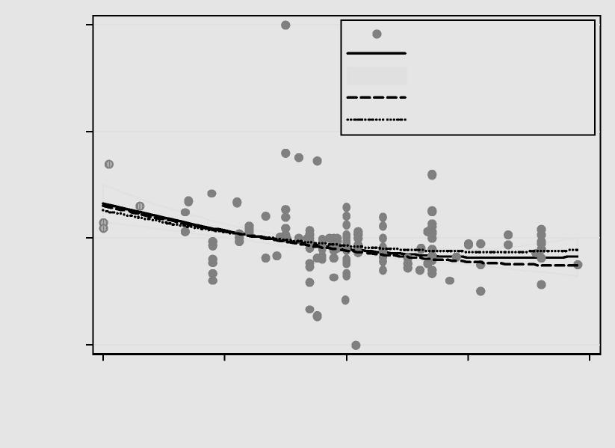
% change in performance per °C
-10 0 10 20
15 20 25 30 35
Temperature (°C)
reported in each study composite weighted 90% CI of composite weighted sample size weighted unweighted
From ”slope of the curve” in Figure 1 we further developed curve for the performance in relation to temperature. This curve is shown in Figure 2. It shows the decrement of performance in relation to maximum. For example, at the temperature of 30 ºC the performance is only 91.1% of the maximum at 21.75 ºC, i.e. the reduction in performance is 8.9%

Figure 2. Normalized performance vs. temperature. Derived from the curve in figure 4. Maximum performance is set equal to 1 at the temperatures where the curves in the figure 1 cross the horizontal axis.

15 20 25 30 35
Temperature (°C)
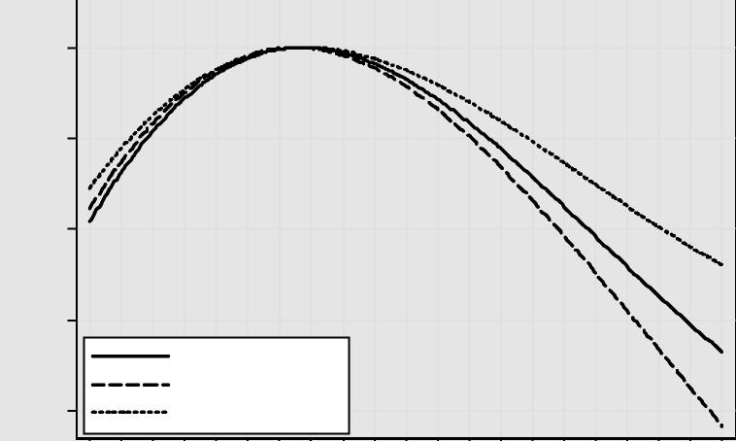
Relative Performance
.8 .85 .9 .95 1
composite weighted sample size weighted unweighted
The equation for the curve with composite weighting factors is
P = 0.1647524. T − 0.0058274. T² + 0.0000623. T³ − 0.4685328
where
P is productivity relative to maximum value
T is room temperature, oC
DISCUSSION
The field studies show a consistent decrease in performance in tasks typical of office work when temperature increase above 24-26 ºC . The tasks in the reviewed studies are quite simple, and it is not clear how well the data apply to performance in actual office environments. However, as the reviewed studies include different specific tasks, the developed weighted relation may well represent average work in the office and may be applicable in many office environments.
The measurements of performance varied greatly from study to study. The unweighted and sample size weighted regression models are based on the assumption that all measurements reflect underlying productivity equally well. Although the combined weights take into consideration the relevance of different

productivity measurements, the assignment of weights is rough and involves subjectivity. Another important assumption is the independence of studies. This assumption is violated in studies performed on the same set of subjects.
CONCLUSION AND IMPLICATIONS
We have developed a quantitative relationship between work performance and temperatures within, below and above the comfort zone. This relationship has a high level of uncertainty; however, use of this relationship may be preferable to current practice, which ignores productivity. The quantitative relationship between temperature and productivity may vary, depending on other building features and on the characteristics of the building occupants and their type of work. Remedial measures will generally also be more cost effective in buildings that have poorer initial IEQ or more existing adverse health effects.
The data summarised in Figure 1 on the relationships between temperature and productivity decrements include studies of routine-type work and several mental tasks. We were not able to distinguish the effect of the type of work in our review. The model we used averages all studies in actual office work or in tasks performed typically in doing office work. The strongest effect on productivity was reported from phone-service work (Federspiel 2004), and the weakest effect from controlled laboratory experiments with female and male students performing various mental tasks (Pepler and Warner 1968, Langkilde 1978, Langkilde et al. 1979). Data suggest that the effect of the temperature may be stronger in actual work that in short-term laboratory experiments where the motivation may weaken the effect of the temperature. As a first approximation, the model is applicable to all types of office work.
High temperatures, in practice, may be associated with low ventiation rate; however, in the studies referred to in the paper, the ventilation was constant, thus the results indicate only the effect of temperature. Low ventilation combined with high temperature would most probably decrease the productivity further due to the increased prevalence of SBS symptoms and other effects.
ACKNOWLEDGEMENT
This work was supported by the Finnish Academy. This work was also supported by the Indoor Environments Division, Office of Radiation and Indoor Air, Office of Air and Radiation of the U.S. Environmental Protection Agency through interagency agreement DW-89-92175001-0 with the U.S. Department of Energy. The authors would like to thank Mark Mendell for his valuable comments and support.

REFERENCES
Allen MA, Fischer GJ, 1978. Ambient temperature effect on paired associate learning,. Ergonomics, 21, 95101
Berglund, L.,Gonzales, R., Gagge A. 1990. Predicted human performance decrement from thermal discomfort and ET*. Proceedings of the fifth international conference on indoor air quality and climate. Toronto, Canada, vol 1:215-220.
Chao HJ, Schwartz J, Milton DK, Muillenberg ML, Burge HA. 2003. Effects of indoor air quality on office workers’ work performance - a preliminary analysis. Proceedings of healthy Buildings 2003. pp 237-243
Djukanovic R, Wargocki, R, Fanger P. 2002. Cost-benefit analysis of improved air quality in an office building. Proceedings of Indoor Air 2002 pp. 808-813.
Fang L, Wyon DP, Clausen G, Fanger PO. 2004. Impact of indoor air temperature and humidity in an office on perceived air quality, SBS symptoms and performance. Indoor Air Journal 14 (Suppl 7) 74-81.
Federspiel CC, Fisk WJ, Price PN, Liu G, Faulkner D, Dibartolemeo DL, Sullivan DP, Lahiff M. 2004. Worker performance and ventilation in a call center: analyses of work performance data for registered
nurses. Indoor Air Journal vol 14. Supplement 8: 41-50.
Fisk WJ. 2000. Health and productivity gains from better indoor environment and their relationship with building energy efficiency. Annual Review of the Energy and the Environment. Vol 25. 2000. pp 537-566.
Fisk WJ, Seppänen O, Faulkner D, Huang J. 2003. Cost benefit analysis of ventilation control strategies in
an office building, Proceedings of Healthy Buildings 2003 Conference. Singapore. December 2003. Vol 3:361-366.
Hansen, S.-O. 1997. Economical consequences of poor indoor air quality and its relation to the total building operation costs. EuroFM/IFMA Conference & Exhibition, Torino, Italy June 1997
Hedge A. 2004. Linking environmental conditions to productivity. Power Point presentation. Cornell University.
Heschong Mahone Group. 2003. Windows and offices: A study of office workers performance and the indoor environment. Prepared for California energy commission. Fair Oaks, California.
Holmberg, I. and Wyon, D.P. 1969. The dependence of performance in school on classroom temperature, Educational & Psychological Interactions, 31, 20p. Malmö, Sweden: School of Education.
Johansson, C. 1975. Mental and perceptual performance in heat. Report D4:1975. Building research council. Sweden. 283 p.
Korhonen P, Salmi K, Tuomainen M, Palonen J, Nykyri E, Niemelä R, Seppänen O, Reijula K. Effect of temperature on perceived work environment, symptoms and self-estimated productivity in office work. Proceedings of Healthy Buildings Conference 2003. Singapore. Vol 3:311 - 317.
von Kempski D. 2003. Air and well being – A way to more profitability. Proceedings of Healthy Buildings 2003 Conference. Singapore. December 2003. Vol 3, 348-354.

Langkilde G. 1978. The influence of the thermal environment on office work. In: Fanger PO and Valbjorn O. Proceedings of the First International Indoor Climate Symporium. Copenhagen.
Langkilde, G., Alexandersson, K., Wyon, D.P. and Fanger, P.O. 1979. Mental performance during slight cool or warm discomfort, Archives des Sciences Physiologiques, 27:511-518.
Link, J., Pepler R. 1970. Associated fluctuations in daily temperature, productivity and absenteeism. No 2167 RP-57, ASHRAE Transactions 1970. Vol 76, Part II:326-337.
Löfberg, H.A., Löfstedt, B., Nilsson, I. and Wyon, D.P. 1975. Combined temperature and lighting effects on the performance of repetitive tasks with differing visual content. In: Proceedings of the 18th CIE Conference, London, UK: International Lighting Association.
Meese, G., Kok, R., Lewis M., Wyon D.P. 1984. A laboratory study of the effects of moderate thermal stress on the performance of factory workers. Ergonomics. vol 27, 1:19-43.
Mortagy AK, Ramsey JD. 1973. Monitoring performance as a function of work/rest schedule and thermal stress. Am J Ind. Hyg. Assoc. J. 34 474-480.
Niemelä, R., Railio, J., Hannula, M., Rautio, S., Reijula, K. 2001. Assessing the effect of indoor environment on productivity. Proceedings (CD) of Clima 2000 Conference in Napoli, 2001.
Niemelä, R., Hannula, M., Rautio, S., Reijula, K., Railio, J. 2002. The effect of indoor air temperature on labour productivity in call centers – a case study. Energy and Buildings. 34:759-764.
Pepler, R., Warner R. 1968. Temperature and Learning: An experimental study. Paper No 2089. Transactions of ASHRAE annual meeting, Lake Placid, 1967:211-219.
Seppänen, O., Fisk, W.J., Faulkner, D. 2003. Cost benefit analysis of the night-time ventilative cooling. In: Proceedings of the Healthy Buildings 2003 Conference. Singapore 2003, Vol 3:394-399.
Seppänen O, Vuolle M. 2000. Cost effectiveness of some remedial measures to control summer time
temperatures in an office building. Proceedings of Healthy Buildings 2000, vol.1 pp.665-660, SIY Indoor Air Information Oy, Helsinki, Finland
Tham KW. 2004. Effects of temperature and outdoor air supply rate on the performance of call center operators in the tropics. Indoor Air Journal 14 (Suppl 7):119-125.
Tham KW, Willem HC. 2004. Effects of reported neurobehavioral symptoms on call center operator performance in the tropics. Proceedings (in CD) of RoomVent 2004 Conference. Coimbra. Portugal
Wargocki P. Estimate of economic benefits from investment in improved indoor air quality in office building. 2003. Proceedings of Healthy Buildings 2003 Conference. Singapore. December 2003. Vol 3,
383-387.
Wyon, D.P. 1996. Individual microclimate control: Required range, probable benefits and current feasibility. Proceedings of 7th International Conference on Indoor Air Quality and Climate, Indoor Air '96. Nagoya, Japan, Vol 2: 27-36.
Wyon D, Wyon I, Norin F. 1996. Effects of moderate heat stress on driver vigilance in a moving vehicle. Ergonomics 39,1,61-75.

